**Recipes For Life**

**Progress Report**

**By Kari McMahon**

**Supervisor: Keith Edwards**

**Project & Background**

The following report outlines the progress achieved up until 30/1/2015 in my honours project with focus on the aims of the project, progress and the challenges and successes so far. The honours project I am working on is Recipes For Life – A cooking application for android devices which focusses on creating a collaborative cooking environment which enables multiple people to collaborate on recipes. The core feature will be the collaborative aspect which enables multiple people to share a cookbook where they can manage recipes together for example adding new recipes or making alternations. The inspiration and motivation for the project came from the recognition that there was no available applications on the app store that enabled people to share and manage recipes together. I felt that as we move more and more into a digital age the benefits of collaborative cookbooks could be lost which is why I feel it is necessary to create application that enables families, friends, colleagues, clubs and people online who have similar interests in cooking to be able to collaborate on recipes together. The intended users for the application is really any age group and gender who have basic experience of using apps and enjoy cooking particularly those who enjoy using technology while cooking.

**Progress**

Progress on the project started in semester one. The semester was predominantly focussed on exploring the project idea to help me analyse if it was a feasible project and then designing the application. The first month or so of the semester was drawing out sketches of how I envisioned the application, brainstorming features and needs for the application, researching current cooking apps and reading papers that focussed on the benefits of collaborative cookbooks. From this I found there was a lot of scope for the application because none of the apps featured the collaborative aspect I hoped to add but a lot of features could also be added to the app that are popular in other recipes apps for example timers and shopping lists that are automatically created based on recipes you own. The papers I read strengthened my motivation for the application as many stated from autobiographical and historical perspectives that collaborative cookbooks were a way to share experiences with others, form relationships and maintain tradition over years. The papers showed the benefits collaborative cookbooks bring and my application will hopefully help bring these benefits to the 21st century. A list of the literature I reviewed can be found in the appendix.

After exploring the project idea I spent the rest of the semester making design decisions. I created more detailed design sketches to explore the application in further detail using Axure. I made technical decisions such as the choice to use a SQL database on the server as well as a SQLite database on the phone which will communicate with each other using PHP and JSON and the operating system I will develop for which is android. The technical decisions were all based on reading and previous knowledge. From making the technical decisions I then developed ER diagrams, class diagrams and a basic testing strategy. I choose to take an Iterative development approach which is an Agile approach which makes you more flexible to change than Waterfall but is less focussed on the customer than an Agile technique like scrum which is very customer oriented. Since the project is my idea I wanted to use a flexible development process but not one completely centred on customer oriented processes because I do not have a customer. In the iterative approach you start with an initial planning stage where you outline design choices, requirements, and plans. You then have an iteration where you design, implement, test and evaluate for a period of time and you modify and change based on things that do not work in the iteration or if priorities change which makes your project adaptable. I plan on having 2 iterations of 6 weeks which contain 3 sprints of implementation and at the end of each iteration do user testing and once the two iterations are complete I plan to evaluate the application against another currently on the market. To manage this approach I created several documents to help manage the project over the year such as Gantt chart to maintain an overview of the full project, a risk assessment to outline possible risks in the project and how I can try to mitigate them, sprint backlogs to manage progress of tasks during the iterations, a logbook which I have used throughout the year as a diary containing rough ideas/sketches, a trello to manage requirements for the sprints and a github to maintain all the project files.

In October of semester 1 I focussed on my ethics application which was accepted in the middle of November. The ethics application outlined my plans to have a focus group where I could gain opinions on my design sketches for my application before implementation, a survey to gain peoples opinion on the application as well as the requirements that are important to them and the cooking tech they are currently using, user testing sessions and an evaluation comparing the application against one that’s currently on the market. So far I have had a focus group with 6 participants about my design sketches which in general gained strong feedback with some minor changes pointed out which will useful to creating a more user centred application at the implementation stage. I sent out my survey which received 19 responses which were helpful in prioritising my key requirements. An initial requirements document was written up based on my own prioritisation of key features it was then re-written taking into consideration the feedback from the survey. The requirements were written in a formal document and are then stored on Trello as user stories in the same priority to help me manage the requirements for each iteration to enable me to be more adaptable to change. The appendix has the original requirements document as well as an image of the Trello backlog I am using.

At the start of the Christmas break I started to focus on implementation. The process involved a lot of setting up and getting used to the Android development environment again which I feel set me back a bit in terms of progress. The main development achievements during the Christmas break was developing the signing up/signing in of users with the syncing between the databases. I had hoped to achieve more during the break but found it more challenging than expected to get set up. There was also a setback in progress when the php on the zeno server as it was not set up for msserver which occurred while the university was on break meaning I couldn’t get it fixed for a while. So instead of waiting I choose to use asp.net instead as it was already set up although it took some time for me to get to grips with asp.net again. I did 2 sprints of my first iteration in the Christmas break but unfortunately not much progress was made in the 2nd sprint as I fell very unwell for around 2 weeks and then was on holiday for a week. Since starting back at university I am just finishing off the feature of adding a recipe in the application but had the challenge of the server being down for a few days. Throughout development I am trying to refactor and add unit tests to test the features every time a feature is complete.

**Successes & Challenges**

The concerns I have for the project is the project is too large scope based on the amount of time spent on implementation so far to get only a small amount done. I am concerned I may not have enough time to get enough developed to demonstrate the core functionalities. Other concerns are predominately focussed on user testing and evaluation I am concerned about being able to get enough participants, the possibility of only being able to have 1user testing sessions instead of the 4 I intended on having user testing sessions because I do not believe I will have enough done in the first iteration to justify a user testing session. The main concerns is time constraints to be able to focus on a lot of development but still have time to accurately test and evaluate as well as write the report and have relevant documentation for the project.

The successes of the project so far is ethics was approved and I have already had a design sketch focus group and sent my survey out and used it towards my requirements. The majority of my design decisions have been made and will only I change based on implementation. I have had regular meetings with my supervisor and I am actively using my log book, project management tools and github to maintain and keep track of the project. I have also made a very rough draft of the report up until the design chapter (not including specification). I have started some development and I am making sure to refactor and unit test after a new functionality is added to the application.

**Aims for the project & looking towards next semester**

My aims for the project is to achieve an application that demonstrates the core functionality of collaboration on cookbooks between multiple people. I aim to achieve an application that is user centred by involving users throughout the application from design to evaluation. I am hoping to achieve an A grade on the project. Next semester most of my time will be focussed on the implementation and user testing of the application, nearing the end of the semester I hope to start my evaluation. Leaving me April to focus on finalising report, documentation and presentation in preparation for submission at the start of May.

**Conclusion**

In conclusion I believe I have made strong progress in my project so far which I hope to maintain. My main concern for the project is the time constraints merged with the large scope of my project as implementation for the project is a lot more complex that I initially thought.

**Appendix**

**Literature List**

Please note the list features all reading used in my dissertation so far. Not just the papers on cookbooks or collaborative cookbooks.

Android, n.d. *Testing Fundamental.* [Online]   
Available at: http://developer.android.com/tools/testing/testing_android.html  
[Accessed 12 November 2014].

Bower, A. L., 1997. *Recipes For Reading: Community Cookbooks, Stories, Histories.* s.l.:University Of Massachusetts Press.

Budiu, R., n.d. *Mobile: Native Apps, Web Apps, and Hybrid Apps.* [Online]   
Available at: http://www.nngroup.com/articles/mobile-native-apps/  
[Accessed 14 Septemeber 2013].

Ferguson, K., 2012. Intensifying Taste, Intensifying Identity: Collectivity through Community Cookbooks. *Signs,* 37(3), pp. 695-717.

Genymotion, n.d. *Genymotion.* [Online]   
Available at: http://www.genymotion.com/  
[Accessed 12 November 2014].

Github, n.d. *About Github.* [Online]   
Available at: https://github.com/about  
[Accessed 12 November 2014].

Gorbsky, M., 2013. *Native vs. HTML5 Applications: Which Approach is Best?.* [Online]   
Available at: http://www.seguetech.com/blog/2013/04/09/native-vs-html-applications-best-approach  
[Accessed 11 November 2014].

IDC, 2014. *Smartphone OS Market Share, Q2 2014.* [Online]   
Available at: http://www.idc.com/prodserv/smartphone-os-market-share.jsp  
[Accessed 11 November 2014].

IDC, 2014. *Smartphone Vendor Market Share, Q2 2014.* [Online]   
Available at: http://www.idc.com/prodserv/smartphone-market-share.jsp  
[Accessed 2014 November 11].

Kotek, B., 2002. *MVC design pattern brings about better organization and code reuse.* [Online]   
Available at: http://www.techrepublic.com/article/mvc-design-pattern-brings-about-better-organization-and-code-reuse/  
[Accessed 13 November 2014].

McCracken, H., 2013. *Who’s Winning, iOS or Android? All the Numbers, All in One Place.* [Online]   
Available at: http://techland.time.com/2013/04/16/ios-vs-android/  
[Accessed 11 November 2014].

Merriam-Webster, 2014. *Cookbook.* [Online]   
Available at: http://www.merriam-webster.com/dictionary/cookbook  
[Accessed 10 November 2014].

Mitchell, J., 2001. Cookbooks as a social and historical document. A Scottish case study. *Food Service Technology,* 1(1), pp. 13-23.

Ruhlman, M., 2012. *So You Want To Write A Cookbook.* [Online]   
Available at: http://ruhlman.com/2012/02/so-you-want-to-write-a-cookbook/  
[Accessed 10 November 2014].

Theophano, J., 2003. *Eat My Words : Reading Women's Lives Through The Cookbooks They Wrote.* Ill edition ed. s.l.:Palgrave MacMillan Trade.

**Gantt Chart**

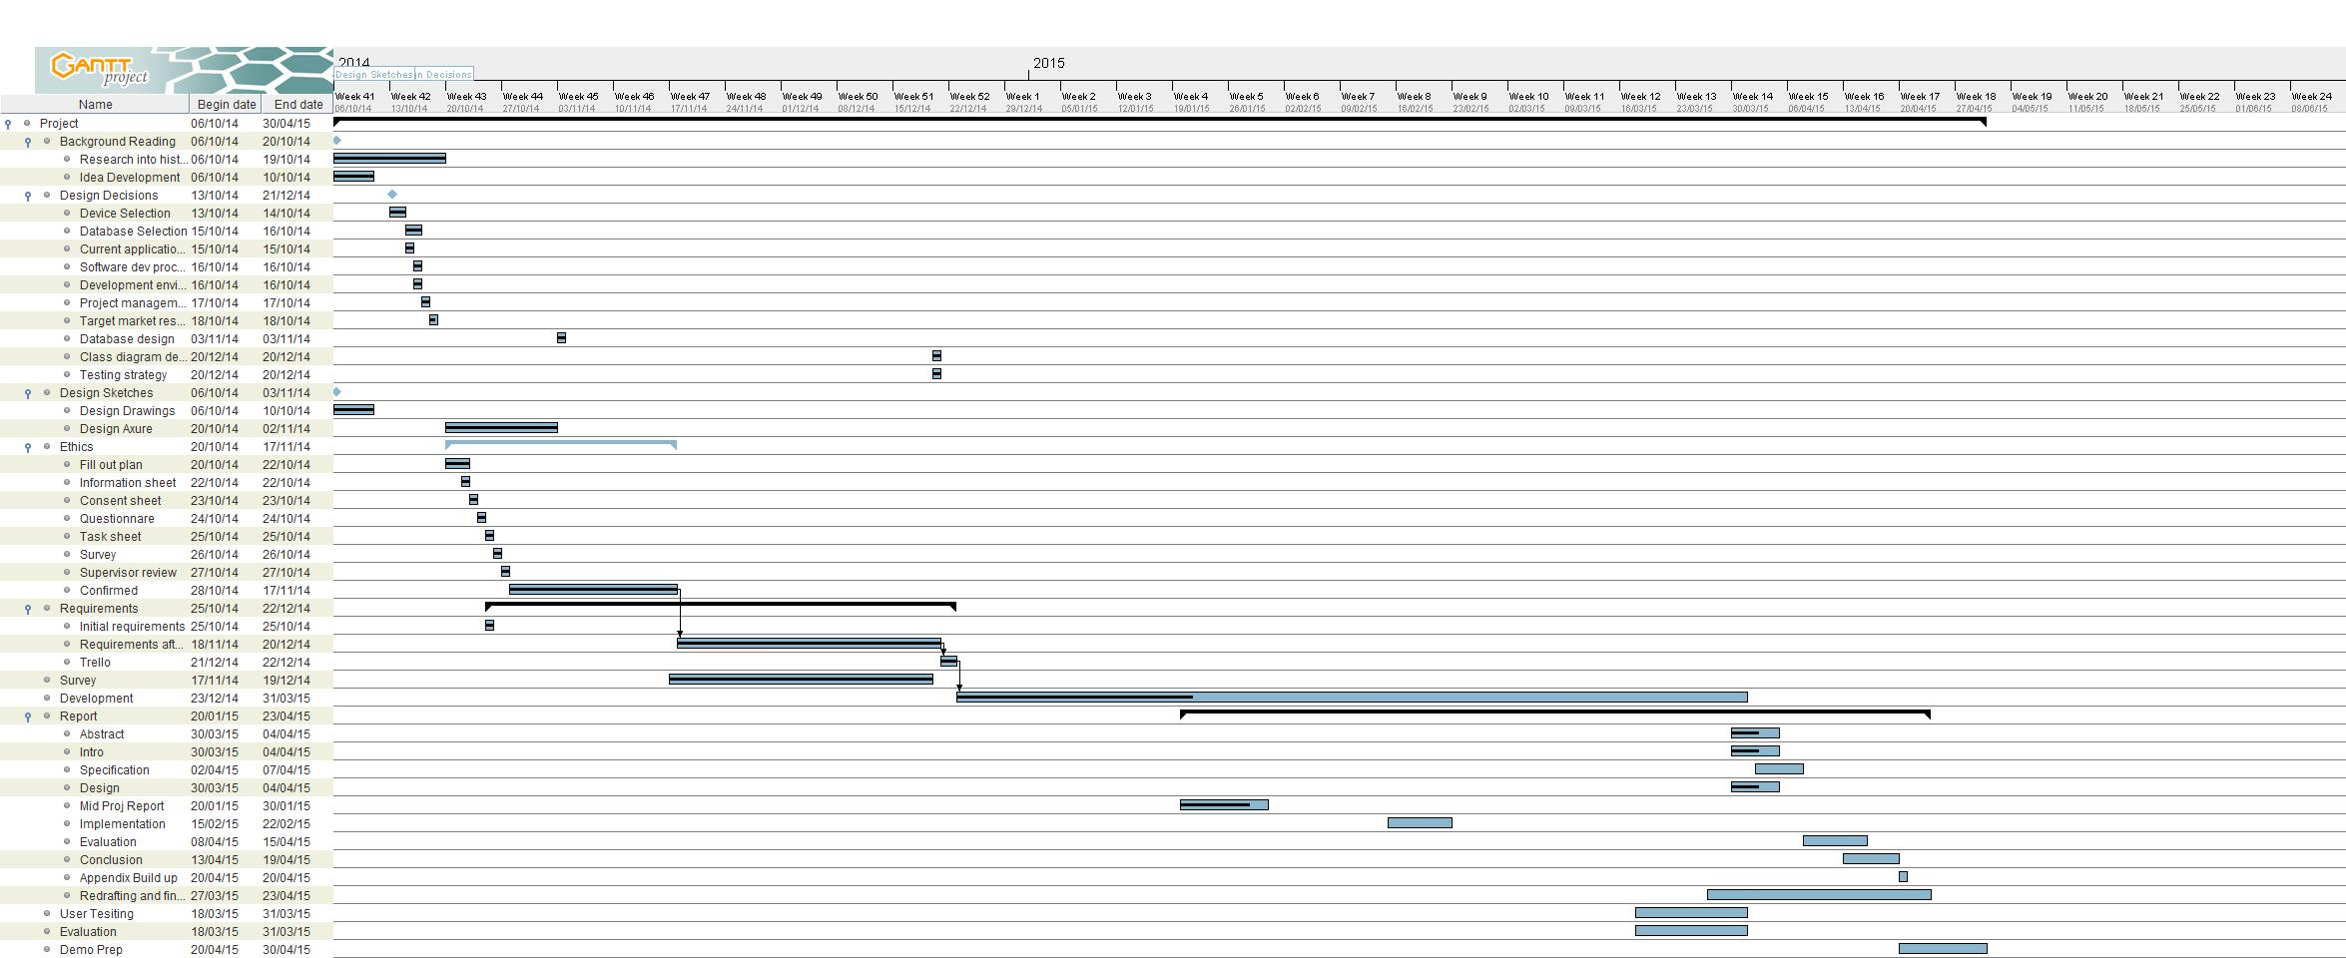

**Requirements**

The original requirements document:

**Functional Requirements**

1. The user shall be able to add, edit and delete recipes.
2. The user shall be able to create an account.
3. The user shall be able to add, manage and delete cookbooks.
4. The user shall be to have collaborative cookbooks where friends, family can add, edit and view recipes/cookbooks.
5. The user shall be able to set a cookbook to public or private.
6. The user shall be able to view recipe in full screen in the kitchen.
7. The user shall be able to view and browse other cookbooks and recipes.
8. The user shall be able to review and ask questions about the recipe.
9. The user should be able to convert measurements.
10. The user should be able to stop the screen sleeping when using a recipe.
11. The user should be able to add recipe or ingredients to a collaborative shopping list in app.
12. The user should be able to print recipes or cookbooks out.
13. The user may be able import recipes from url into app.
14. The user may be able to scale ingredients up or down
15. The user may be able to enlarge font when using recipes in kitchen.
16. The user may be able to add photos of handwritten recipes to app.
17. The user may be able to share recipes via social media.
18. The user may be able to see favourite/popular/featured cookbooks.
19. The user may be able to set a kitchen timer in the app.
20. The user may be able to create a profile.
21. The user may be able to view users profile and follow them.

**Non Functional Requirements**

1. The application shall be built for Android devices.
2. The application shall use a SQL database on the server and SQLite database on the Android device.
3. The application should work offline.
4. The application should update the database when wifi available.
5. The application should receive a high SUS score.
6. The application should pass all the units tests.
7. The application should pass all tests set out in testing strategy.

To be adaptable and work in an iterative manner I use Trello to store the requirements in a backlog in the following manner. Trello allows me to move requirements around based on priority changes and move them into sections for when I’m developing and working on them and labelling the requirements different colours based on progress. An image of my backlog is below:

